
PROJECT PACK 10
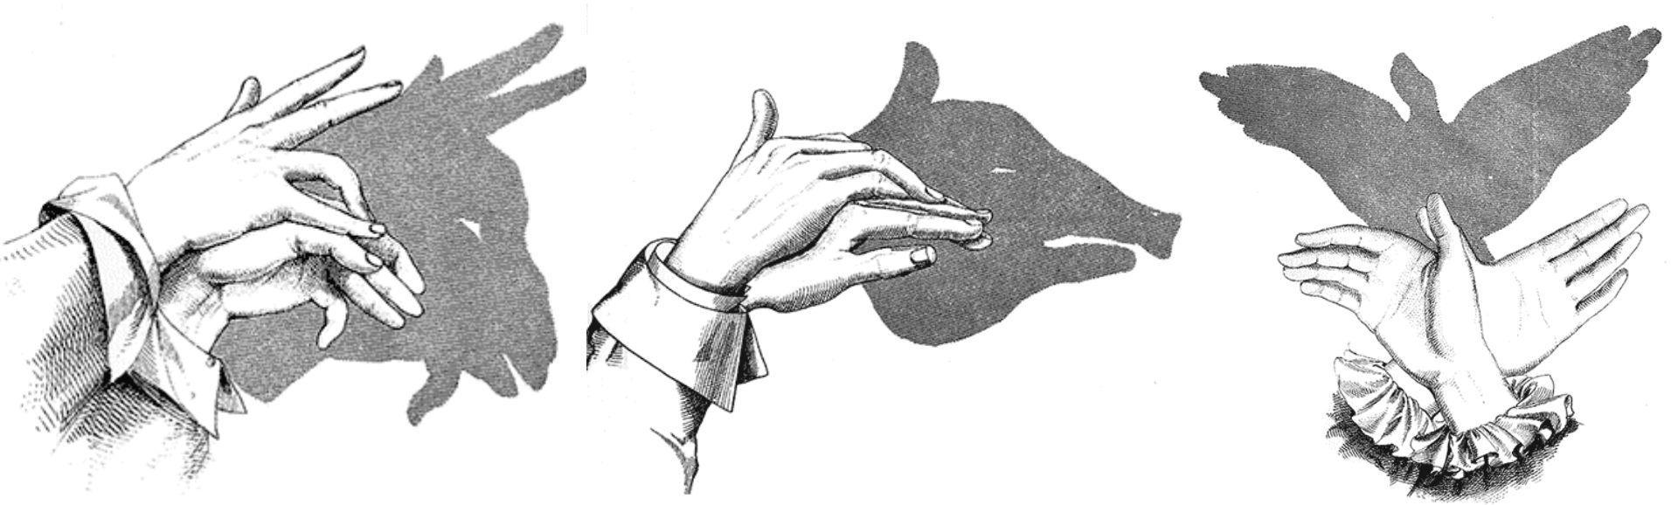

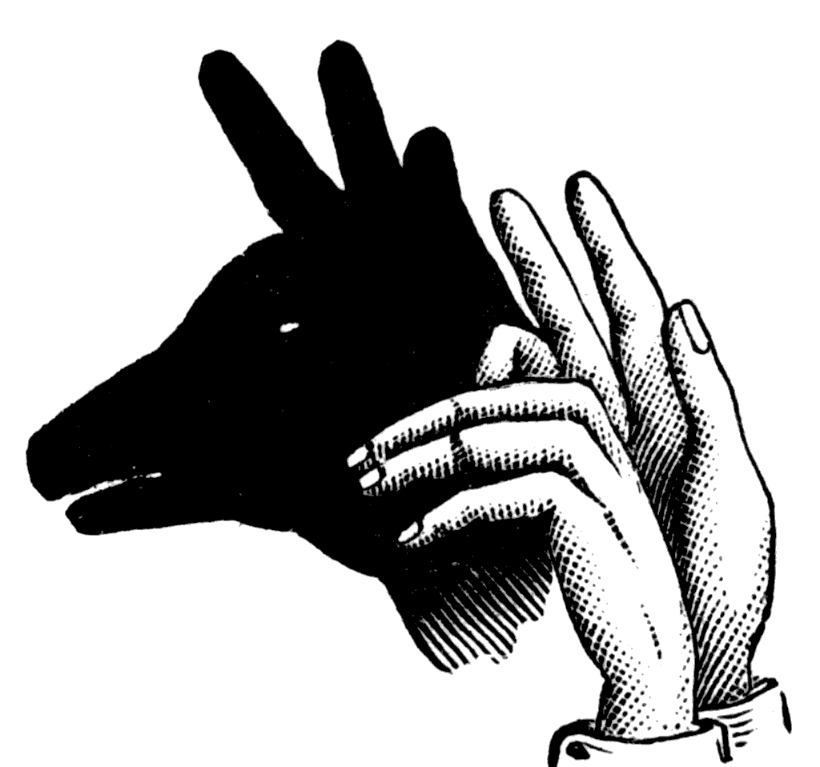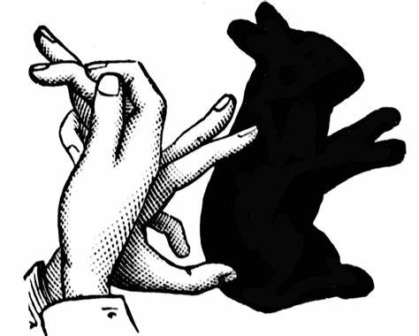HAND SHADOW GAME
One of the lovely things about hand shadow puppets is that you don't need anything other than a light source, a blank wall or screen and a pair of hands, to be able to make them!
Despite their simplicity, these puppet shows can be extremely beautiful and entertaining, and the basic puppets can be learned and performed by anyone!

How To Make Hand Shadows
You need a directional light source AND a light-coloured wall or screen
To get the best results when shining a lamp against the wall, turn off other lights in the room. Then your shadow will be really strong!
Use a wall in your home that has little around it, a white or light colour, with enough space to show the shapes you make. You can also use a lamp or torch - shining against a blank wall...

Use your hands OR your favourite object at home
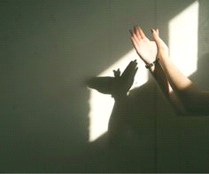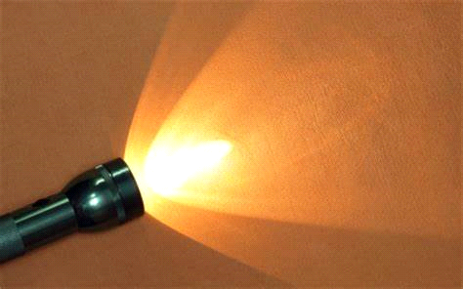This is a chance to experiment! Your hands can make all sorts of fun shapes, but so can things you find around the house.
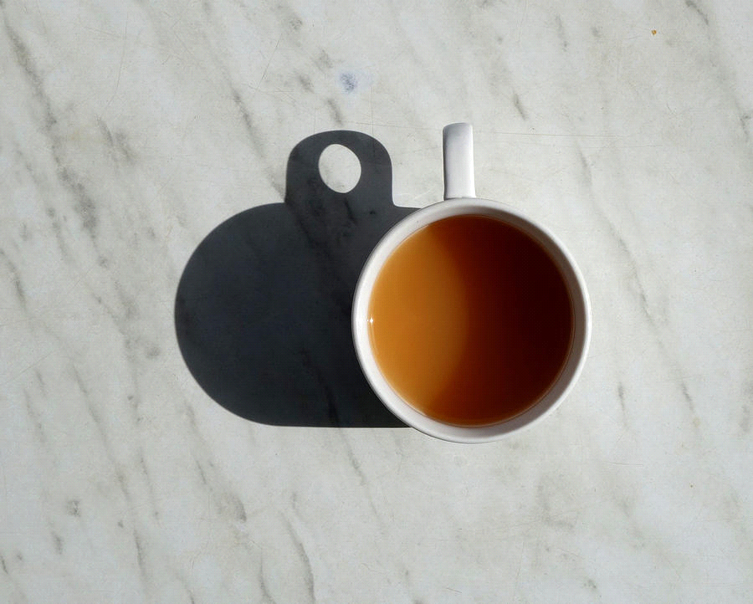Try placing yourself in front of the light, or getting a friend at home to do this, ask them to turn this way or that way or closer to the lamp or further away from it.
What happens?
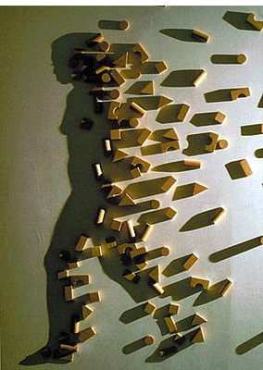
What happens when you rotate your favourite object in front of the light?

Fukuda is an artist that plays with shadow. Using scrap objects to make nonsense sculptures, then shining the light on it - it looks like something familiar!
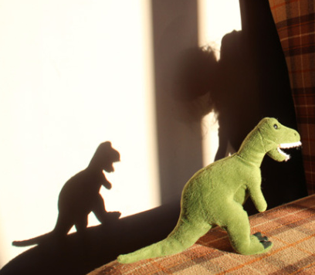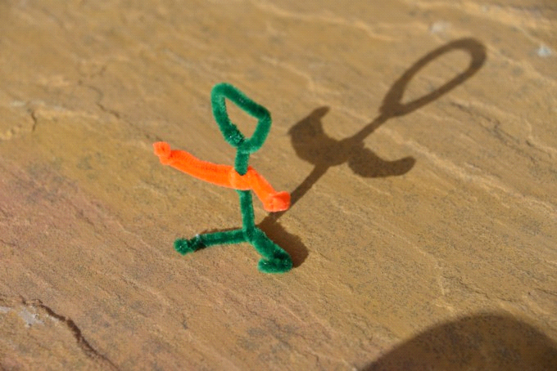Try making nonsense sculptures with things at home or seeing what funny objects you can find, to see what you can create with the light shining on them.

Lastly, we need… just a little imagination!

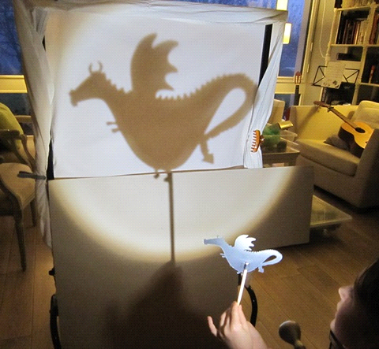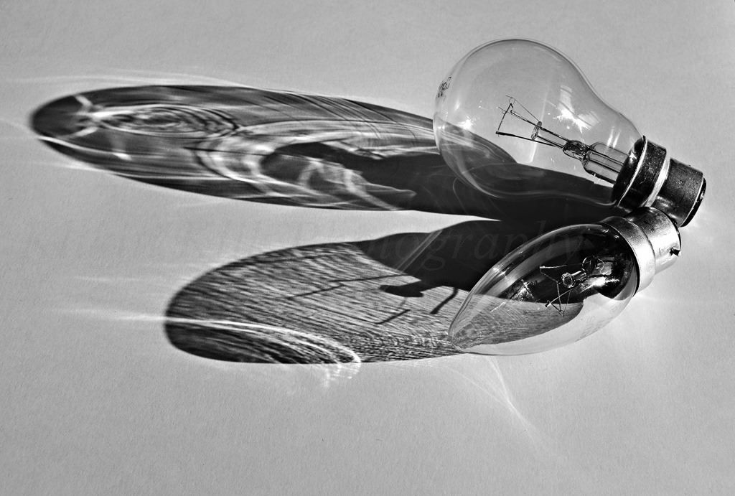If you have any favourite things in the house that have character, you can hold them up to the light & see how big you can make them become!

For other ideas to practice, here are some easy hand shapes you can make for fun. Ask for help if you need it.
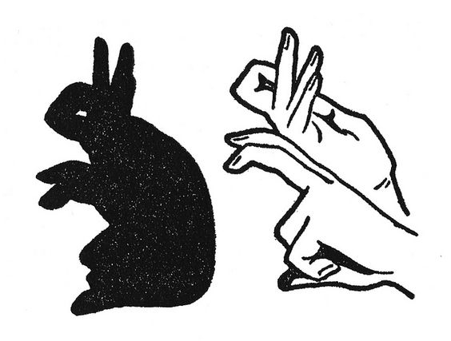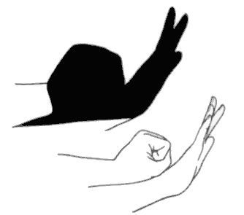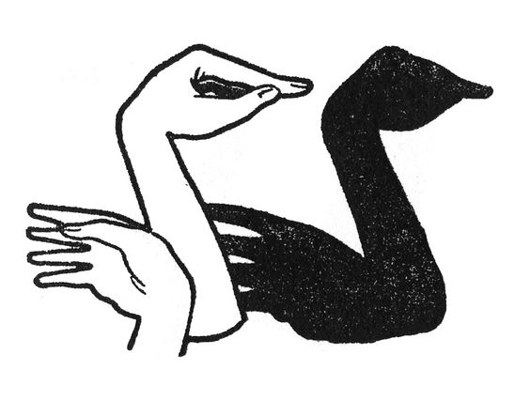CAN YOU RECOGNISE THE SHAPES BELOW?

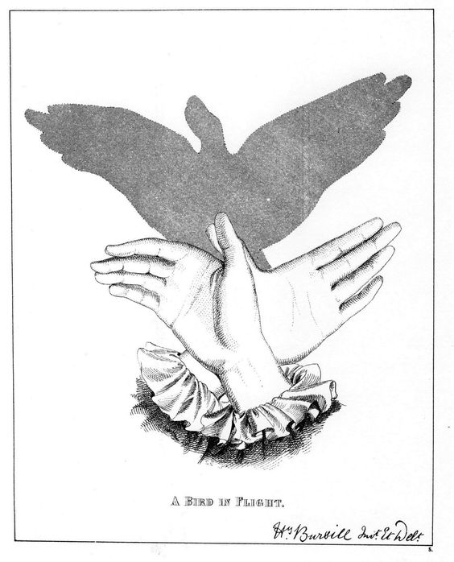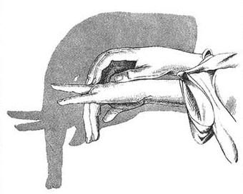CREATE SOME OF YOUR OWN AS WELL!
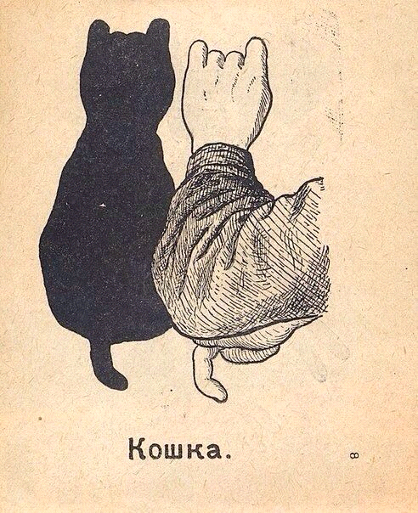
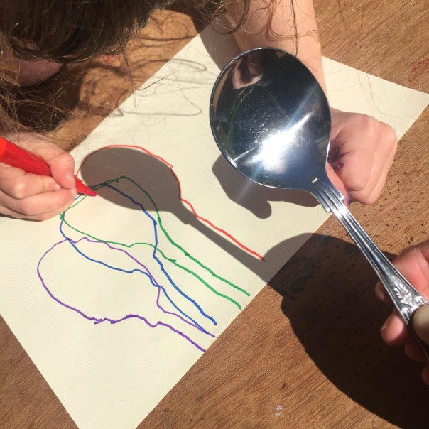SHADOWS BECOME ART
Now you have learned how to make shadow shapes with your hands & with objects around the house, how can you use them for art?
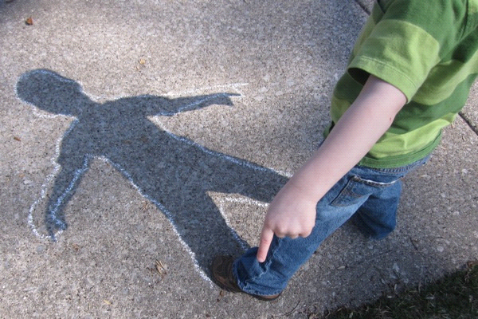

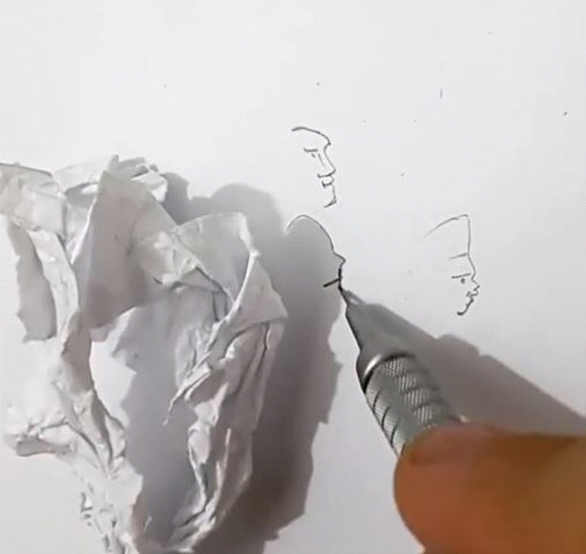

Attach paper to the wall or table where you are making your shadow.
Now try drawing around the shapes!
With a pencil or pen - follow the outline of the Shape of your Shadow.
Get Creative! Use different coloured pencils & pens to colour the outlines in. Make funny marks around each edge...
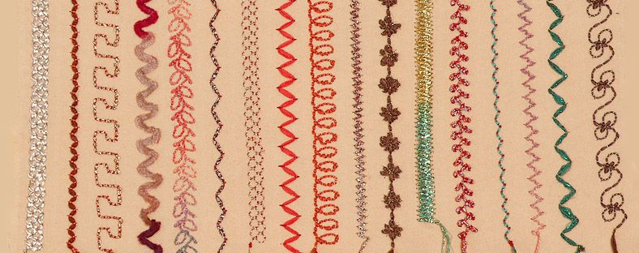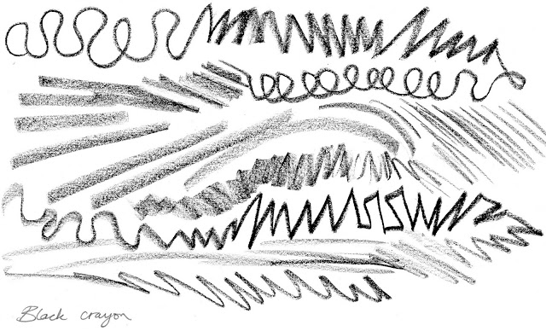

ALL OF THE ARTWORKS YOU HAVE MADE BY USING SHADOWS. TRY ANYTHING & EVERYTHING YOU CAN THINK OF.
HAVE FUN!!
SKETCHES BECOME TEXTILE & WIRE SCULPTURE
If you have drawn as many as you feel like, but you still want to collect ideas, maybe you can take photos of shadows you make to add to your creative collection?
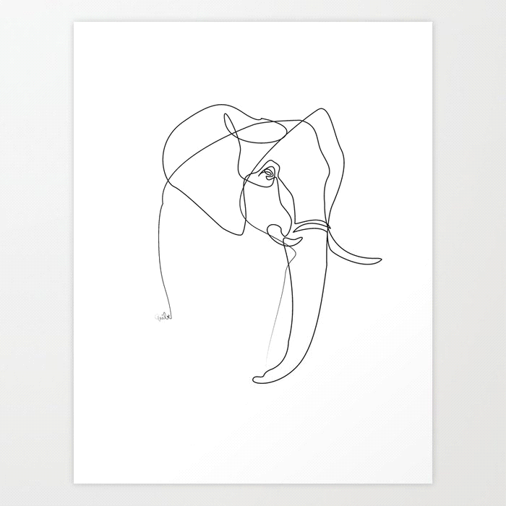The outlines you have drawn are very valuable. Keep them for when we are back in class. We can all share our work we did at home & use the designs or many things.
Two things we can use designs for are:
1. PRINTING
We can print the whole shadow OR the outline onto bags, aprons, clothing or to hang on the wall as art.
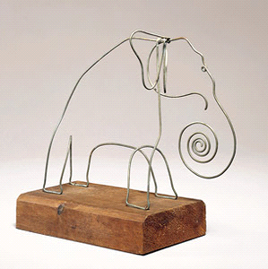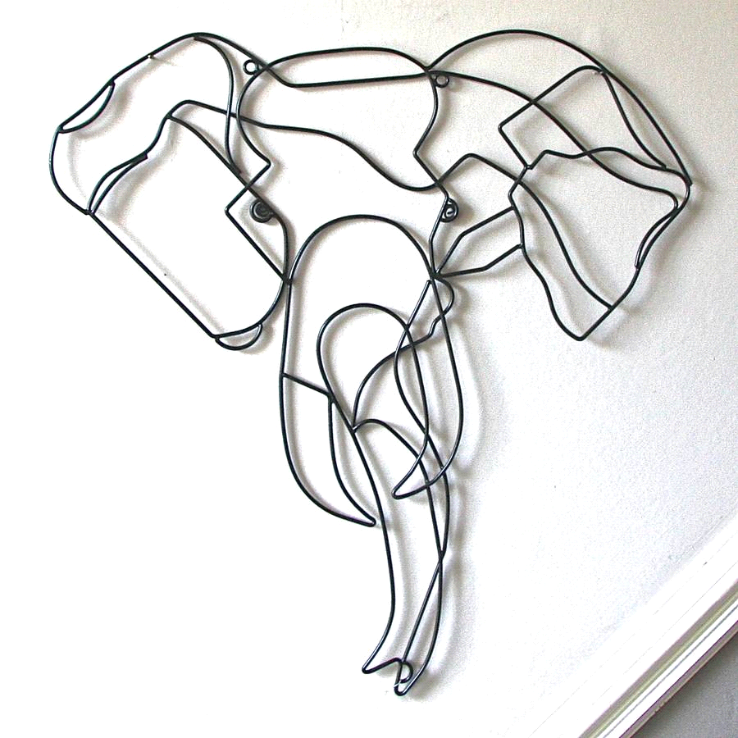2.TEXTILE WIRE SCULPTURE
Some may be flat or 3D wire sculptures....

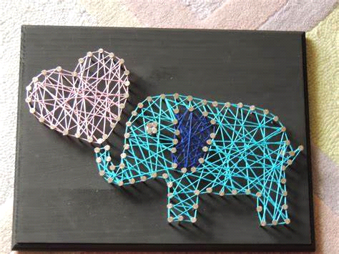We can't wait to see everything you do & make sculptures & prints of your designs!

